**SOFT SKILL ASSIGNMENT MODULE-1**

1. **Thank you Email**

**Subject: Thank you for the promotion!**

**Dear Mrs sunil shah,**

**I wanted to thank you for my recent promotion to as a manager and let you know how much I appreciate your support. It's such a great opportunity that I've looked forward to for some time and I'm grateful for your confidence in my abilities.**

**I'm grateful for giving me opportunity for manage all projects. I look forward to change old pattern off manage and add some rule for employee and make you proud with this new position.**

**Thanks again for your help. I'm truly grateful for your support**

**Sincerely ,**

**Akhil pethani**

**2. Letter of Apology**

**Dear Principal Rahul sir ,**

**I hope this letter finds you well. I am writing to sincerely apologize for the late submission of my assignment titled " make a HLR ", which was due on 5 JULY . I deeply regret not being able to submit it on time and take full responsibility for the delay.**

**My late submission was due to I have a family function so I am not available for 7 days and go out of station for attend very big function of grating ceremony . I understand that timely submissions are essential for maintaining discipline and fairness, and I truly regret any inconvenience this may have caused.**

**I have now completed the assignment and am ready to submit it. I will manage my time better in the future to ensure this does not happen again. If there is any penalty for the delay, I fully accept it and will improve my academic responsibility.**

**Once again, I apologize for this mistake and appreciate your understanding. Thank you for your time and consideration.**

**Sincerely ,**

**Akhil pethani**

**3.Reminder Email**

**Subject line: Appointment Reminder for deal confirmation**

**Dear akash gupta,**

**Just a reminder from sardar print and pack pvt . ltd about your appointment on 09/07/2025 at morning 10 o’clock.**

**To reschedule, please respond to this email or call akhileshpethani@gmail.com.**

**We look forward to welcoming you soon!**

**Regards,  
Team sardar print and pack pvt.ltd**

**4. Quotation Email**

**Subject: Quotation Email for company bill**

**Dear Jignesh sardhara,**

**I hope this email finds you well. My name is pethani akhil and I am the operator of your packing section at sardar print and pack pvt.ltd.**

**We are currently in the process of maintain the all side pasting machine and folding machine to buy a new part and other products.**

**We look forward to receiving your quotation and working with you in the future.**

**Warm regards,**

**Akhil pethani**

**There is a copy of quotation .**

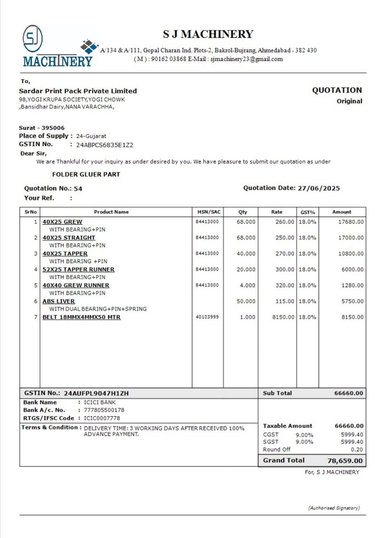

**5. Resignation Email**

**Subject : Resignation akhil pethani**

**Dear Rahul sir,**

**Please accept this email as formal notice of my resignation from my position as QA at Tops Technology, effective 07 July, 2025.**

**I am grateful for the opportunities, membership and support I’ve received here. My time at Tops Technology has been instrumental in my professional growth and I value the relationship and experiences I’ve gained.**

**To ensure a smooth transition, I am happy to assist in training my replacement, documenting processes and completing current projects before my departure.**

**Thank you again for everything. I wish you and the team continued success, and hope we can stay in touch.**

**Your Sincerely,**

**Akhil pethani**